Gloria Feldt – Author, Keynote Speaker, President and Co-Founder of Take the Lead

February 2nd, 2016:
Gloria Feldt specializes in achieving bold and audacious goals that advance women in society and at work. As co-founder and president of Take The Lead, she has created the most comprehensive initiative to prepare, develop, inspire, and propel women to take their fair and equal share of leadership positions across all sectors by 2025. As the bestselling author of No Excuses: 9 Ways Women Can Change How We Think About Power, Gloria is an acclaimed expert on women, power, and authentic leadership and an inspiring keynote speaker who gives practical “Power Tools” for life and leadership.
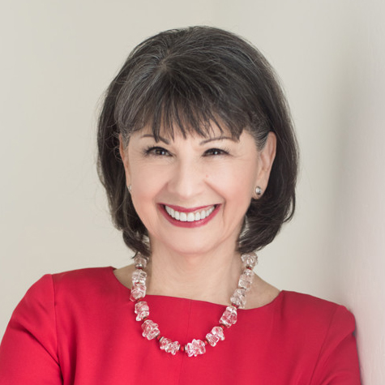People magazine calls her the “voice of experience.” Gloria’s expertise in women, power and leadership comes from a deep well of personal knowledge gained on the frontlines. Her journey from teen mom and high school dropout from rural Texas to president and CEO of the world’s largest reproductive health and advocacy organization, Planned Parenthood Federation of America, to visionary leader for women’s equality inspires both men and women. Among other honors, she was named by Vanity Fair one of “America’s Top 200 Women Leaders, Legends, and Trailblazers,” Glamour’s “Woman of the Year,” a She Knows Media Inspiring Woman, and a Women’s eNews 21 Leaders for the 21st century.
Author of four books, including New York Times bestseller Send Yourself Roses written with Kathleen Turner, she teaches “Women, Power, and Leadership” at Arizona State University.
Both a newsmaker and a commentator, Gloria has been widely quoted and published, including the New York Times, Washington Post, USA Today, Politico, Salon,
The Daily Beast, Forbes.com, Fast Company, Time.com, and Huffington Post, and magazines including Glamour, Elle and Ms. She has appeared extensively on CNN, MSNBC, The Today Show, Good Morning America, and The Daily Show.

